Order Of Service

Singing: Psalm 31—CW page 77

Reading: Psalm 77—Comfort In Remembering

Opening Hymn: TLH 1

Reading: Acts 10:24-33

Request Hymn: CW Supplement 702

Reading: John 20:1-10

Sermon Hymn: TLH 446

Sermon Text: Daniel 6:5-9

Setting The Trap

Prayer

The Apostles’ Creed, TLH page 12

Holy Communion

The Lord's Prayer

The Blessing

Closing Hymn: TLH 447

* * * * * * * * * * *

Bible Study: Lambs: Lady Slipper
Sheep: Romans 11:33-36
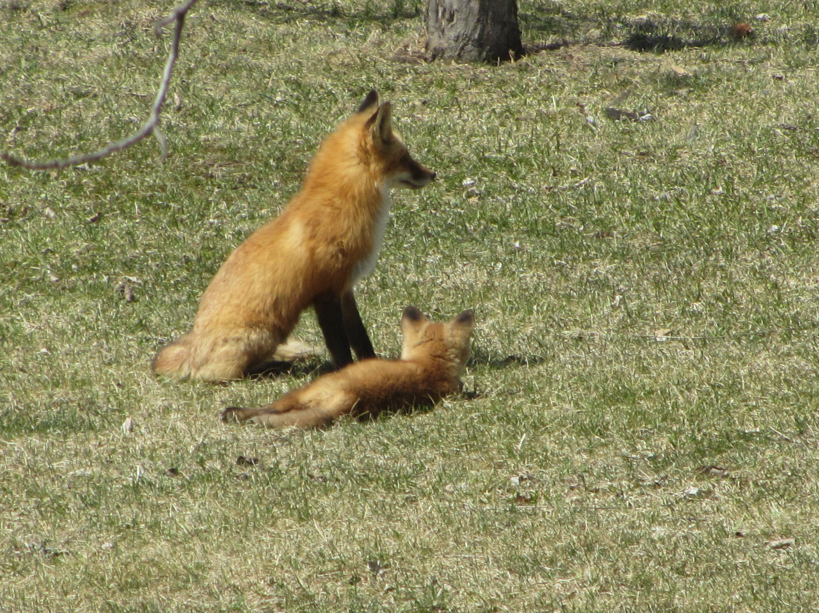

Mother And Child

Water
Of
Life

10 June 2018

W A T E R O F L I F E

Independent Christian Church—Conservative Lutheran Doctrine

Worship Service: 9:30 a.m. Bible Study: 10:45 a.m.

Larry Cooper, Pastor E-Mail address:
111 N. Ridge Road lcooper@wateroflife.cc
Coon Valley, WI 54623 Web Site:
Phone: (608) 452-2105 www.wateroflife.cc

* * * * * * * * * * * * * * * * * * * * * * * * * * *

Sermon Text: Daniel 6:5-9

Setting The Trap

* * * * * * * * * * * * * * * * * * * * * * * * * * *

Daniel 6:5 Then said these men, We shall not find any occasion against this Daniel, except we find it against him concerning the law of his God.
:6 Then these presidents and princes assembled together to the king, and said thus unto him, King Darius, live for ever.
:7 All the presidents of the kingdom, the governors, and the princes, the counsellors, and the captains, have consulted together to establish a royal statute, and to make a firm decree, that whosoever shall ask a petition of any God or man for thirty days, save of thee, O king, he shall be cast into the den of lions.
:8 Now, O king, establish the decree, and sign the writing, that it be not changed, according to the law of the Medes and Persians, which altereth not.
:9 Wherefore king Darius signed the writing and the decree.

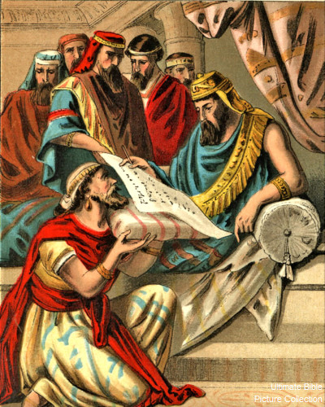

The Power Of The Pen

